EE-363 Power Electronics

Assignment #1

Assignment date: 16 March 2022

Submission Deadline: 22 March 2022

*Name: RAFAY AAMIR GULL*

*Roll no: BSEE19047*

**Question #1**: please select components of your choice from the given list of categories below and make characteristics table for those components also include the link of the website where you can buy those components online as well as their prices, In the end you have to go to hall road and buy any 10 of those components and paste a picture of you/ your group while standing in front of a component shop in this assignment.

List:

1. 3 Zener diodes.
2. 5 Diodes
3. 3 PnP transistors
4. 3 NpN transistors
5. 3 N-type Mosfets
6. 3 P-type Mosfets

Diode:

|  |  |  |  |  |  |  |  |  |  |  |
| --- | --- | --- | --- | --- | --- | --- | --- | --- | --- | --- |
| **Model** | **Forward Voltage Drop** | **Reverse Voltage** | **Max operating Temp** | **Reverse Current** | **Forward Current** | **Maximum Current** | **Recovery Time** | **Cost/Price** | **Where to buy** | **URL** |
| **1N34A** | 1 V | 65 V | 75 C | 500 mA | 1 mA | 200 mA | <2000 ms | Rs 17.00 | Evelectronic. | <https://www.evselectro.com/1n3cc4a-germanium-diode-5096> |
| **1N4007** | 1.1 V | 1000V | +175 C | 5 uA | 1 A | 30 A | 2 us | Rs 1.0 | Hallroad.org | <https://hallroad.org/1n4007-rectifier-diode-in-pakistan.html> |
| **1N5404** | 1.2 V | 400 V | +150 C | 100 u A | 3 A | 200A | >500 ns | Rs 5.0 | Hallroad.org | <https://hallroad.org/1n5404-400v-3a-rectifier-diode-in-pakistan.html> |
| **1N4005** | 0.93-1.1 V | 600 V | +150 C | 5 us | 1 A | 30 A | 2 us | Rs 5.0 | Daraz.pk | <https://www.daraz.pk/products/200pcs-10-values-rectifier-diode-orted-kit-1n4003-1n4004-1n4005-1n4006-i217612008.html> |
| **1N4003** | 1.1 V | 200 V | + 125 C | 5 uA | 1 A | 30 A | 5 us | Rs 5.0 | Daraz.pk | <https://www.daraz.pk/products/200pcs-10-values-rectifier-diode-orted-kit-1n4003-1n4004-1n4005-1n4006-i217612008.html> |

Zener Diode:

|  |  |  |  |  |  |  |  |  |  |  |
| --- | --- | --- | --- | --- | --- | --- | --- | --- | --- | --- |
| **Model** | **Forward Voltage Drop** | **Nominal Voltage** | **Max operating Temp** | **Reverse Current** | **Forward Current** | **Maximum Current** | **Recovery Time** | **Cost/Price** | **Where to buy** | **URL** |
| 1N751A | 1.5 V | 5.1 V | 200 C | 0.2 A | **20 mA** | 70 mA | 25 ns | Rs 2.0 | Epro.pk | <https://epro.pk/product/12v-1w-zener-diode/> |
| 1N4742A | 1.2 V | 12 V | 150 C | 5 uA | 21 mA | 76 mA | 500 ns | Rs 17.0 | Daraz.pk | <https://www.daraz.pk/products/4-pieces-1n4742a-12v-1w-zener-diode-do-41-i102844046.html> |
| 1N5333B | 1.2 V | 3.3 V | 200 C | 300 uA | NA | 380 mA | NA | Rs 12.0 | American Microsemico-nductor | <https://store.americanmicrosemiconductor.com/1n5333b.html?mcid=7> |
| 1N2810B | 1.0 A | 12 | 175 C | 10 uA | 10 SA | 10 A | 500 ns | Rs 5.0 | chipsmall | <https://af.chipsmall.com/Products/1N2810B_13509348.html> |

BJT – Bipolar Junction Transistor:

|  |  |  |  |  |  |
| --- | --- | --- | --- | --- | --- |
| **Type** | **Models** | **Pd** | **VCB (V)** | **VCE (V)** | **VEB (V)** |
| **NPN** | **2N2222** | 500 mW | 60 | 40 | 5 |
| **2N3904** | 625 mW | 60 | 40 | 6 |
| **2N3859** | 30 V | 30 | 30 | 4 |
| **PNP** | **2N3906** | 625 mW | 40 | 40 | 6 |
| **2N2904** | 60 V | 60 | 40 | 5 |
| **2N3634** | 140 V | 140 | 140 | 5 |

MOSFETs:

|  |  |  |  |  |
| --- | --- | --- | --- | --- |
| **Type** | **Models** | **VDS (V)** | **VGS (V)** | **Rise Time** |
| **N-channel** | **IRF640** | 200 | 20 | 60 ns |
| **2N6823** | 600 | 20 | 100 ns |
| **2N7012** | 60 | 20 | 13 ns |
| **P-channel** | **2N6804** | 100 | 20 | 140 ns |
| **IRF7329** | -12 |  | 8.6 ns |
| **IRFR9014** | 60 |  | 63 ns |

Voltage Regulators:

|  |  |  |  |
| --- | --- | --- | --- |
| **Model** | **Vout (V)** | **Iout (A)** | **Vin (V)** |
| UA78M33 | **3.3V** | 500m | 25 |
| L78L33C | 100m | 30 |
| LM7805 | **5V** | 1 | 35 |
| LM140LA-5.0 | 3m | 35 |
| LM7812K | **12V** | 1.5 | 35 |
| LM140LAH-12 | 3m | 35 |

Pictorial Representation of Purchased Components:

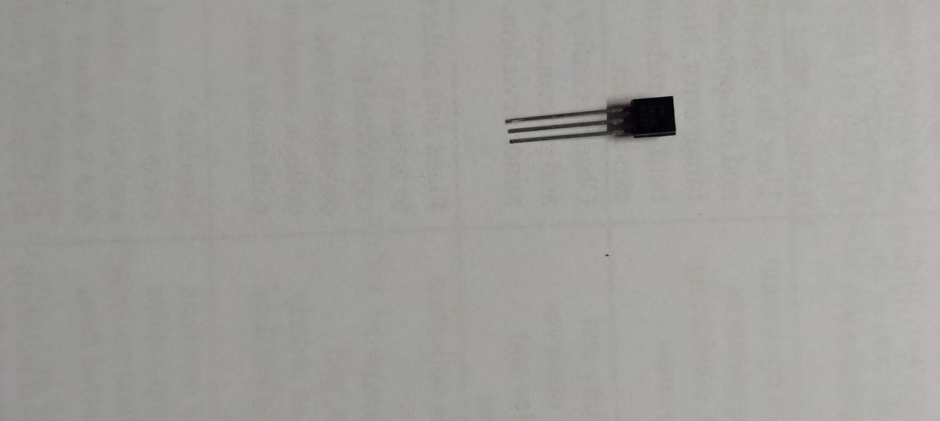

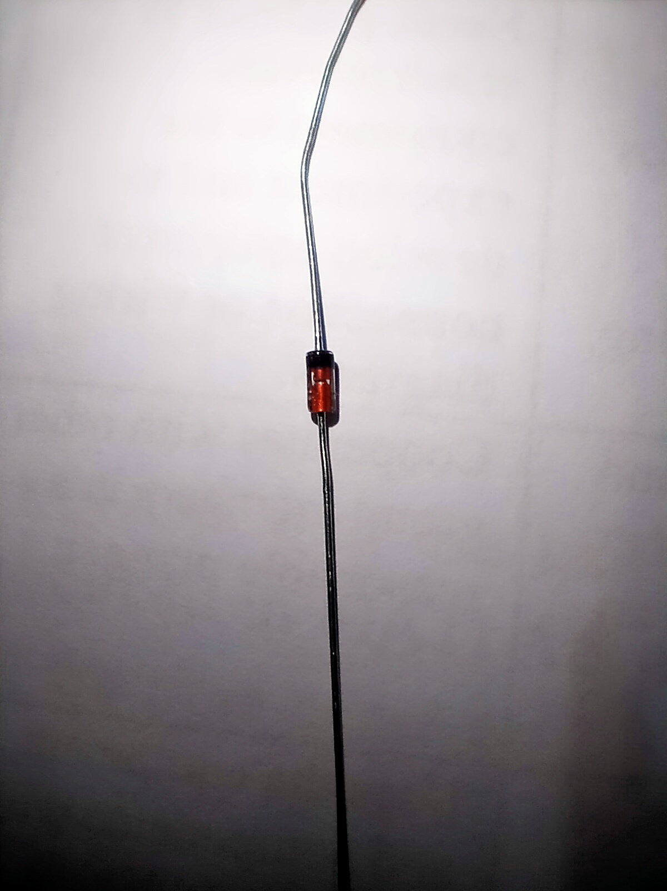

An Awkward picture while purchasing from hallroad

